# User Manual

|  |
| --- |
| Food Management System  User Manual |
| By Christopher Dunkling |

Contents

Analysis 3

Background Identification Of The Problem 3

How A Computerised System Can Help With This Problem? 3

Description of Current System 4

Identification of Prospective User 4

Would Anyone Be Interested In A Computerised System? 4

Primary User 5

Identification of User Requirements 6

Answers to the Questionnaire – My mother 6

Answers to the Questionnaire- My aunt’s family of six 7

Answers to the Questionnaire- Friends family of four 7

Answers to the Questionnaire - Grandparents 8

Review of Similar Already on the Market 9

Data Sources and Destinations 10

Analysis Data Directory 11

Data volumes 11

Logical Data Flow Diagrams 12

E-R model 15

Identification of Objects 15

Objectives 16

Appraisal of Potential Solution 18

Objectives and limitation 18

Architecture 18

Computer Platform 18

Program Language 19

Implementation 19

Design 20

Overall System Design 20

Fundamental Implementation objectives 20

The Prototype Stage Of Design 20

Application Design Decisions 21

IOPS 24

Top Level System Flow Diagram 25

Food Item Add Flow Diagram 26

Food Item Delete Flow Diagram 27

Descriptions Of Modular Structure Of System 28

Process Diagram 28

Database Design 29

Object Orientated Planning 31

Product Class 31

Definition Of Data Requirements 32

Stepwise Refinement 33

User Interface Design 34

Form Navigation 41

Algorithm 42

Class Design 47

Testing 48

Input and Output Testing 48

Adding a product 48

Deleting a product 50

Search products 51

Tracking Updates in the Stock and Product databace 51

Maintenance 56

Code for Outpan Request 56

Code for Delete Request 57

Forms in design view 59

User Manual 64

Using the program 69

Getting Started 69

Functions 73

**Adding items (which have a barcode)** 73

**Adding items (which do not have a barcode)** 74

**Deleting items** 75

**Searching for items** 76

**Details on product screen** 76

Appraisal 77

Comparison of Project Performance Against Objectives 77

Potential for Future Developments 80

User Feedback 80

**Introduction**

According to latest government reports *(Placeholder1)* the average UK family is wasting nearly £60 a month by throwing away food, that accumulates to 7 million tonnes of food in the every year of which 4.2 million tonnes is going straight from fridges and cupboards into the bin. This is wasting a valuable resources and harming the environment

Researchers have found:

With the modern busy life style most food we buy is based on what we think we need or may have run out of plus what’s on promotion, this means a lot of food is buy we already have and conversely forget to buy food we have run out of.

The food is then put in the relevant in cupboards, fringes and freezers sometimes in an organised way but many cases almost random

With the ever increasing amounts of food stored in the house, it becomes difficult to remember what food we do have, were it is stored and most importantly when it will expire, so some food gets completely forgotten about or we forget how long we have had it for and it expires and has to be thrown out.

User Manual Page 2

**Installation**

1. Run the exe file
2. Select where you want to store the program
3. Start the shortcut on desktop.

User Manual Page 3

**Using the program**

**Getting Started**

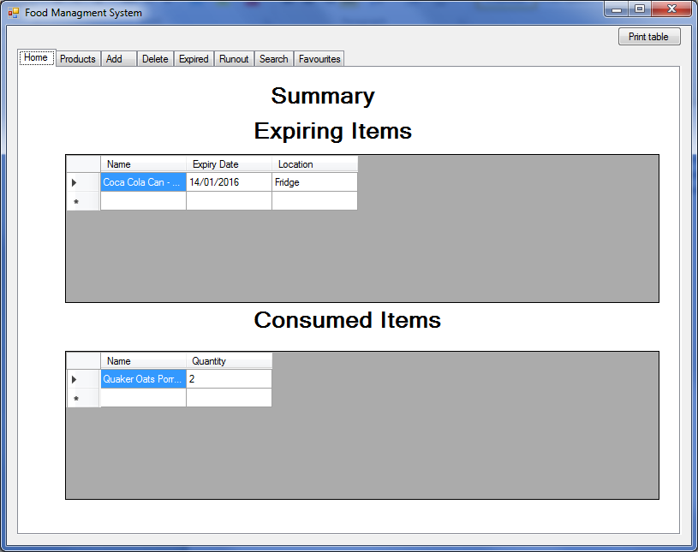When you first boot up the program you will be shown this screen:

You have seven tabs: Home, Products, Input, Delete, Expiring, Runout and search

**Home** (above)

This is the main tab that you see every time you start the program and gives a summary on the expiring items and consumed items.

**Products** (below)

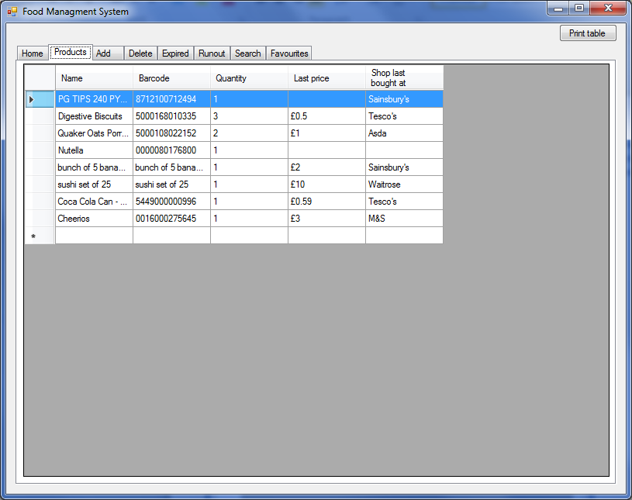This shows all the products you have and their quantities. It will also display the last price and last shop bought from.

User Manual Page 4

**Add** (below)

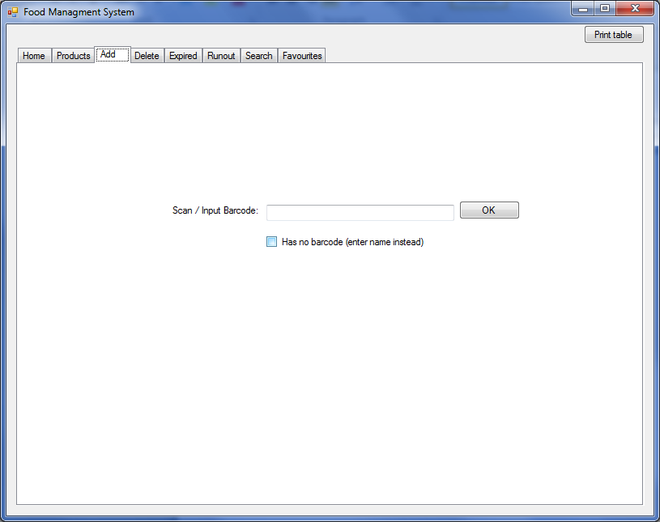This is the tab which you use to add products to the database which can be added via scanning/manual input

**Delete** (below)

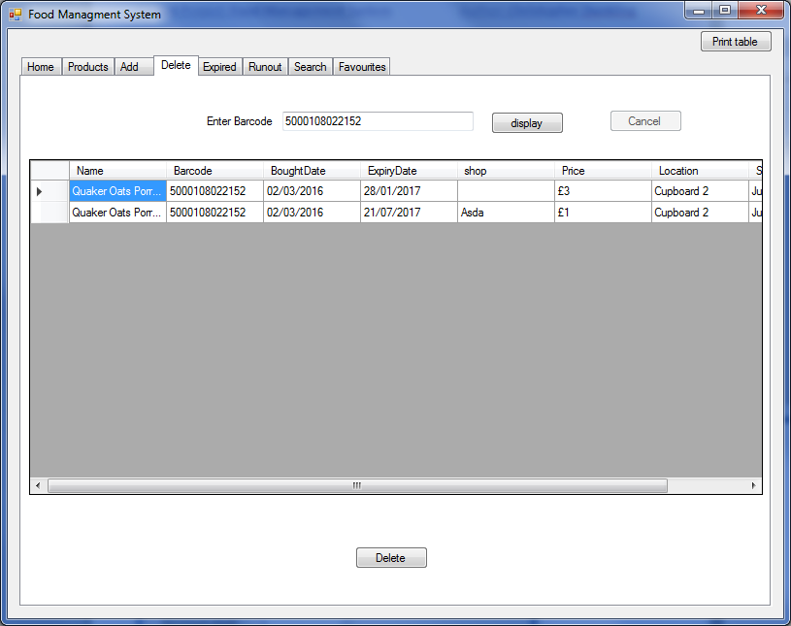This is the tab which you use to delete stock. This will decrease the quantity and remove the selected item.

User Manual Page 5

**Expiring and Runout** (Below)

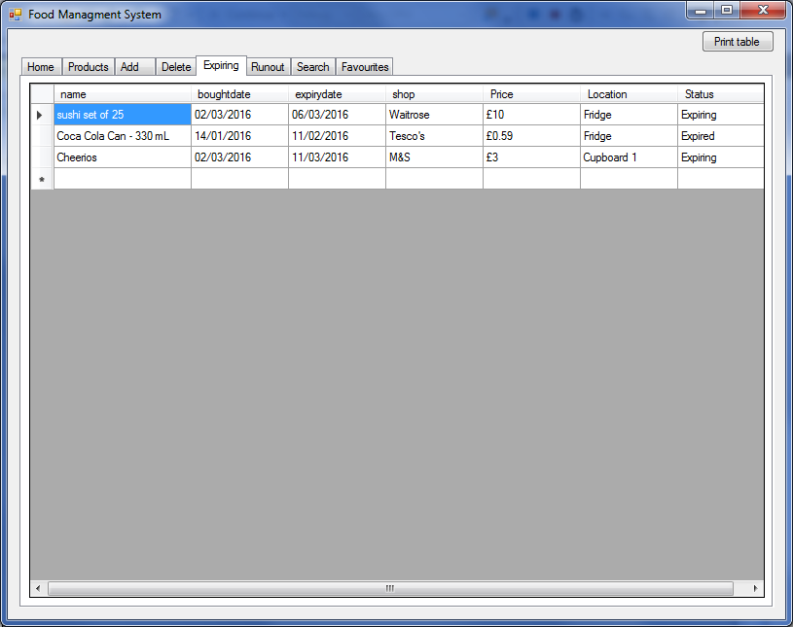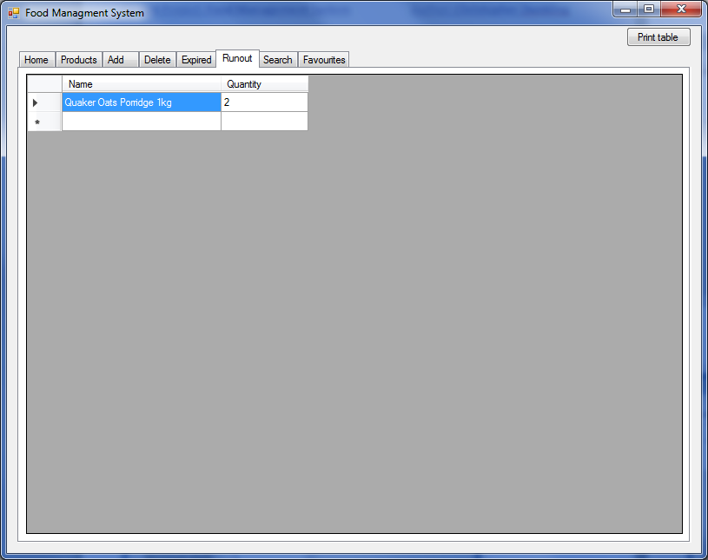These tabs warn about items that are low in quantity or are reaching/reached their expiry date

**Search** (below)

This tab allows the user to search for products

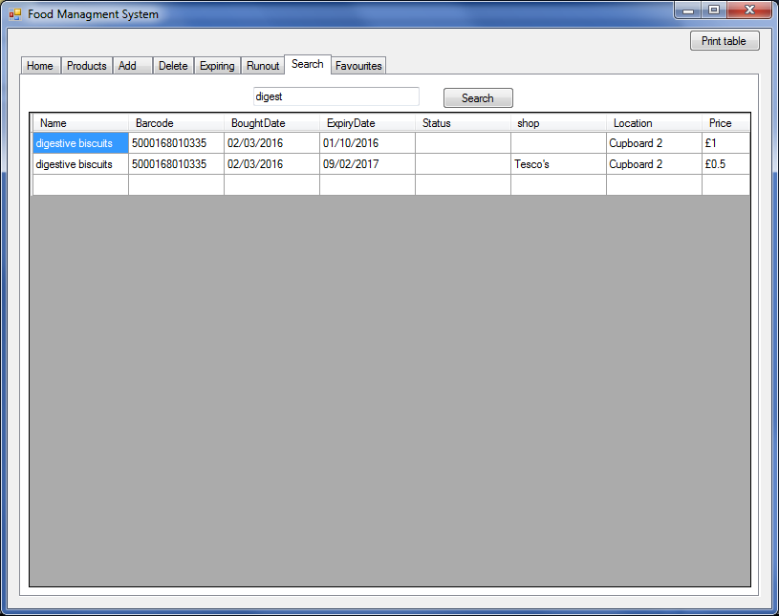

User Manual Page 6

**Favourites** (below)

Contains the products that have been marked as favourite so they can be tracked easier

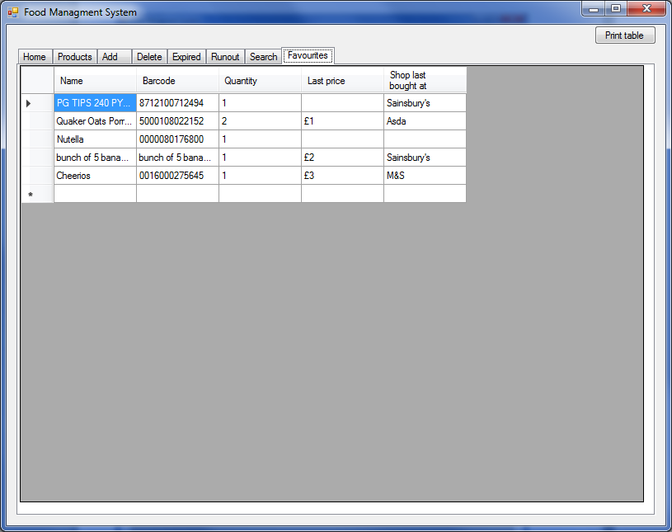

User Manual Page 7

**Functions**

**Adding items (which have a barcode)**



1. Navigate to input tab
2. Scan/input barcode
3. You will then be presented with this screen:

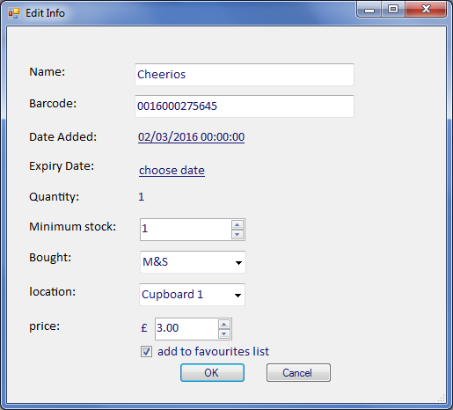

User Manual Page 8

1. You need to fill in:

|  |  |
| --- | --- |
| **Name** | anything can be inputted but commas will be removed |
| **Barcode** | automatically filled in from the scanned barcode |
| **Date added** | date is selected by using the popup calendar. Defaults to today’s date |
| **Expiry date** | works the same as date added. It will ask when expiry date is before today’s date |
| **Minimum stock** | this is the amount where if the quantity goes under this number it will be issued as running out |
| **Bought** | This is the shop where the item was bought from. Select from the list or input your own. It can also be left blank |
| **Location** | This is where the item is stored in the house. Select from the list or input your own. It can also be left blank |
| **Price** | This is the price of the item. Use the up and down buttons to alter the number or input a number. Putting the number as 0 will indicate that do not know/care about the price and when in database will be blank. |
| **Add to favourites list** | This allows you to add the product to favourites as an item which used regularly. |

1. Press ok to add the product to the database. It should then be visible in the products tab

Note that the process can be cancel at any time by pressing cancel or closing the window.

**Adding items (which do not have a barcode)**

1. Navigate to input tab
2. Tick the “has no barcode” box
3. Instead of inputting a barcode, input the name
4. Continue as normal

User Manual Page 9

**Deleting items**



1. Navigate to delete tab
2. Input/scan barcode
3. Press display
4. This will list results relating to barcode and enable the delete button.
5. Select a row and press delete button
6. The quantity for that item should have decreased and the instance you deleted gone

User Manual Page 10

**Searching for items**



1. Navigate to search tab
2. Enter the phrase or word relating to the product you are trying to find
3. Press search

**Details on product screen**

1. Navigate to product tab
2. Select row
3. Press space
4. This will show you all the stock items for that product and gives you the ability to delete them as well